Day 56 - Intermediate+

Rendering HTML/Static files and Using website templates …

Using Flask

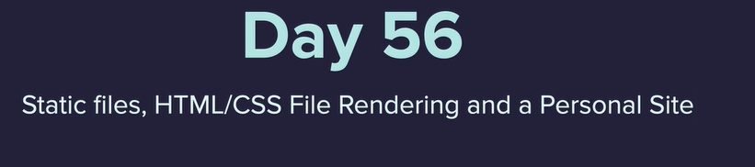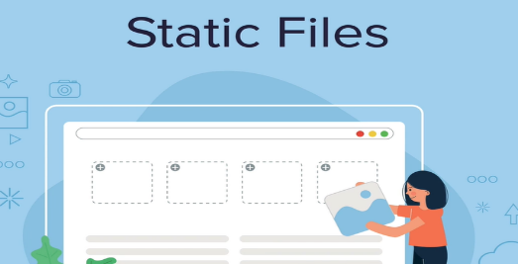

Personal name card application

<https://flask.palletsprojects.com/en/1.1.x/quickstart/#rendering-templates>

server

# boiler plate to spin up the server  
from flask import Flask  
app = Flask(__name__)  
@app.route("/")  
def home_route():  
 return "<h1>Home route</h1>"  
  
if __name__ == "__main__":  
 app.run(deb

path to create HTML file

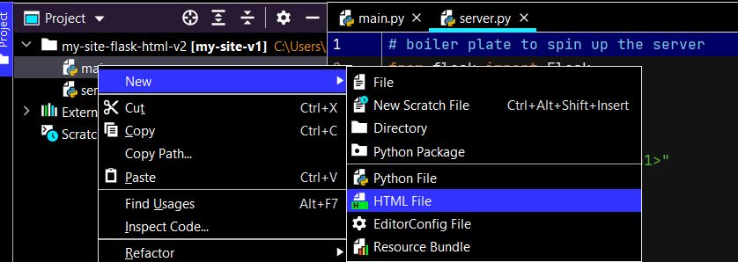

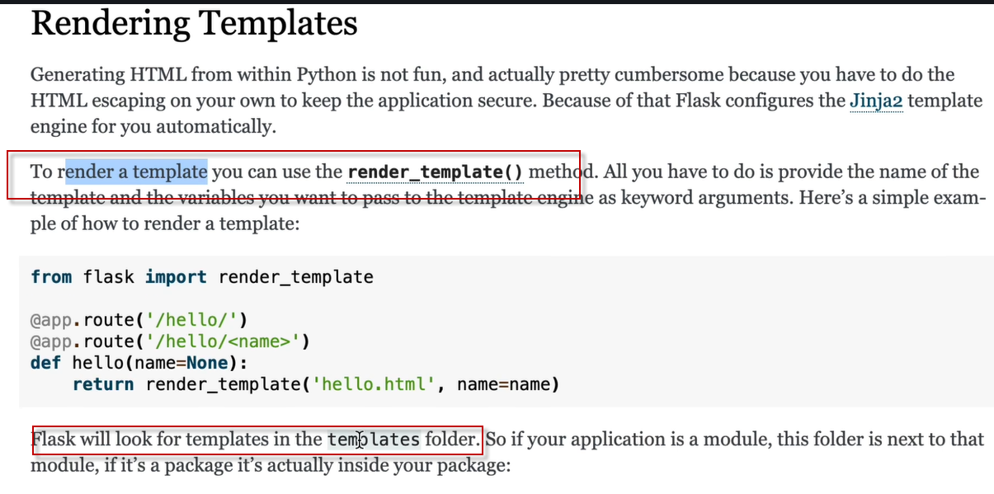

Templates

<https://html5up.net/>

images

<https://unsplash.com/>